## Sales Distributions for different Genres across different regions

Find top 5 publishers in the database based on global sales and then find out sales distributions for each genre across North America, Europe, Japan, Rest of the world(Others).

## Plots:

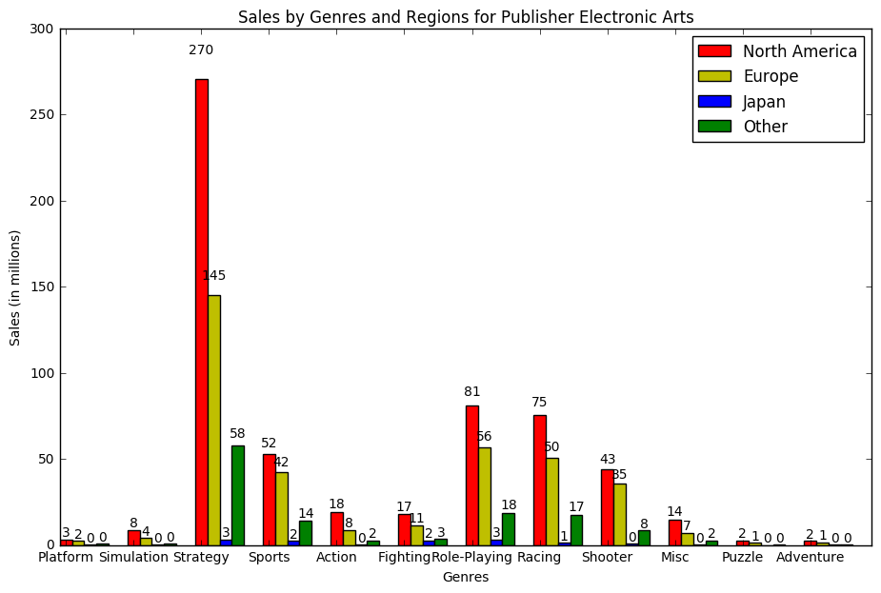

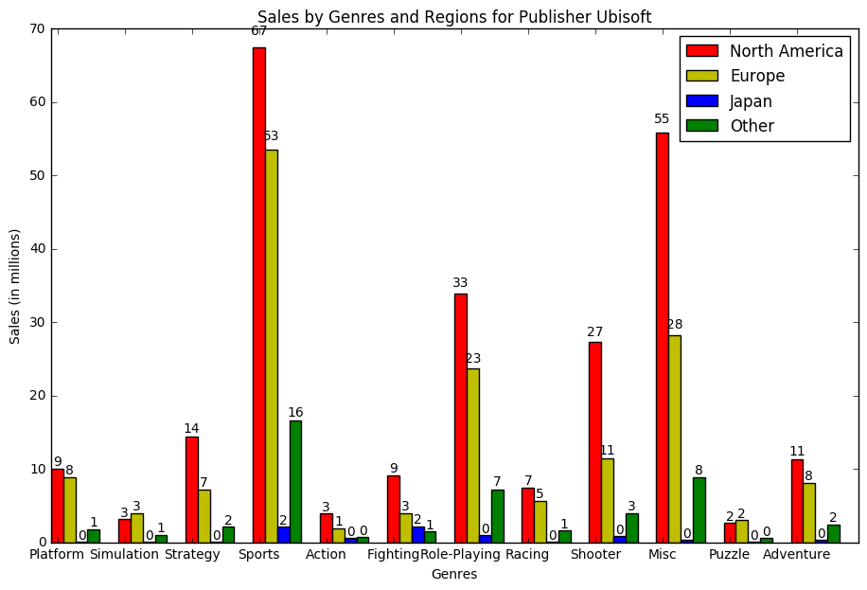

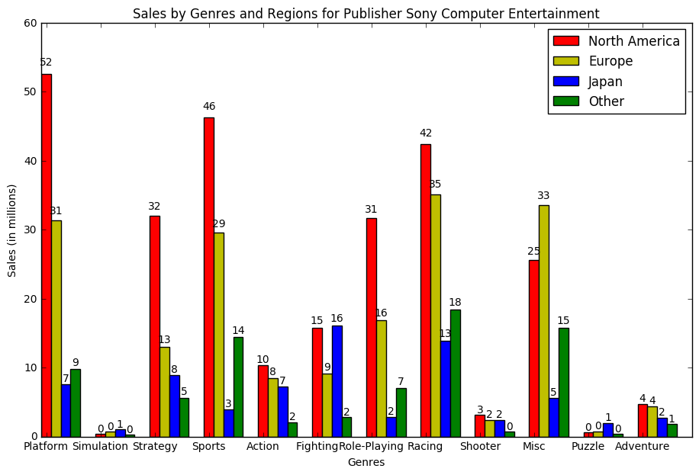

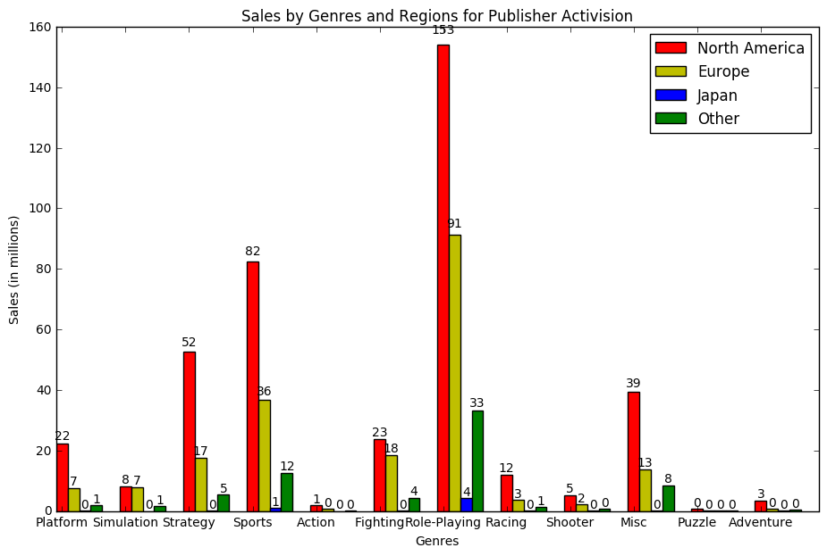

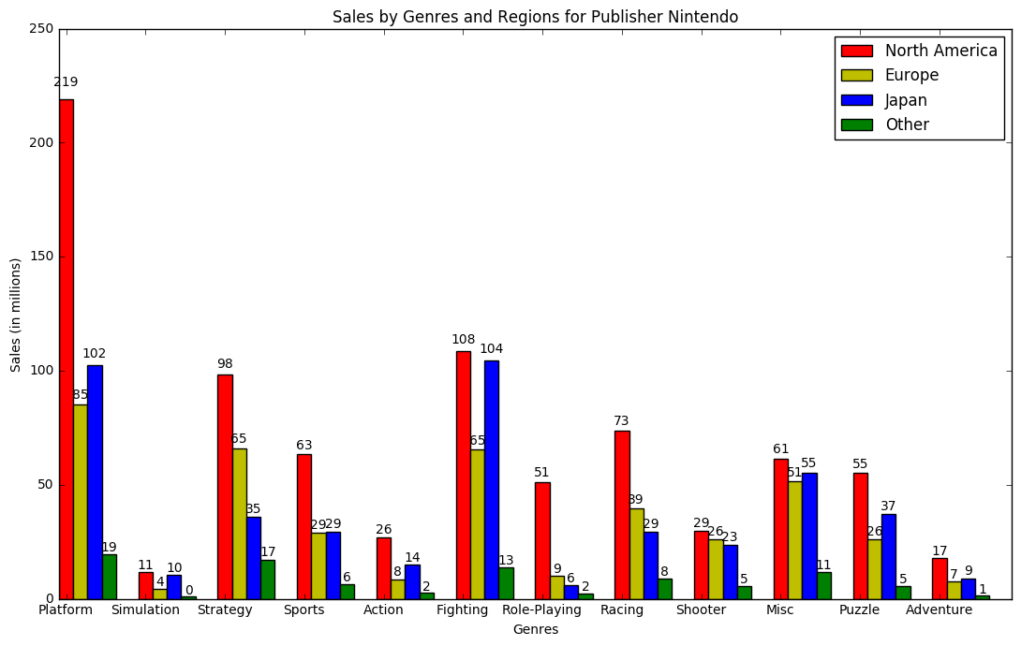

## Conclusion

Top 5 publishers based on the global sales are: Electronic Arts, Ubisoft, Sony Computer Entertainment, Activision and Nintendo.

From the above plots, we can see that:

1. North America is the biggest market for games in Platform genre followed by Strategy Genre. With Electronic arts and Nintendo being the major publishers.
2. Nintendo is has done better sales in Japan (based on sales) as compared to the other regions.
3. Nintendo has sales for almost all its genres whereas other publishers are bit inconsistent across the genres and have sales for one or two specific genres.
4. But overall North America and Europe is the main hub for video games sales in the world.

## Trends for Sales per year for top 5 publisher

For different regions plot trends for sales over the years for each of the top 5 publishers based on global sales. We have considered years as buckets of 5 years, tried to plot total sales for each of those buckets in North America, Europe, Japan and Rest of the world (Other).

## Plots:

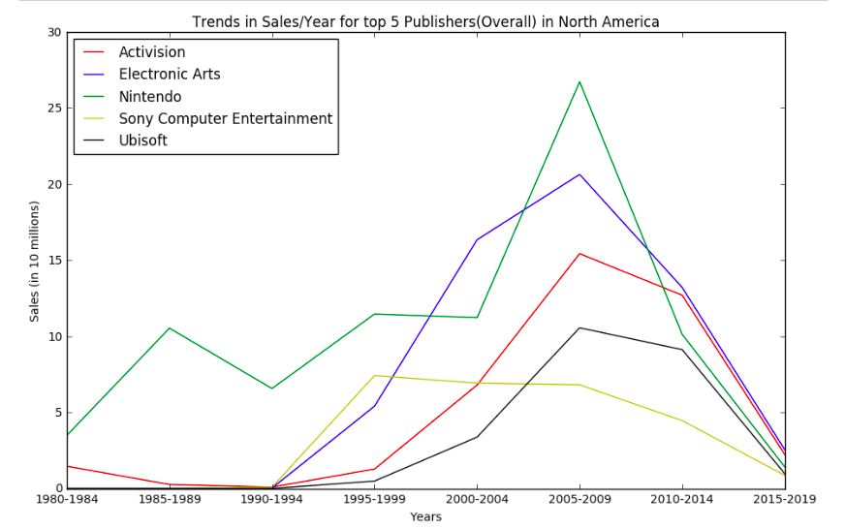

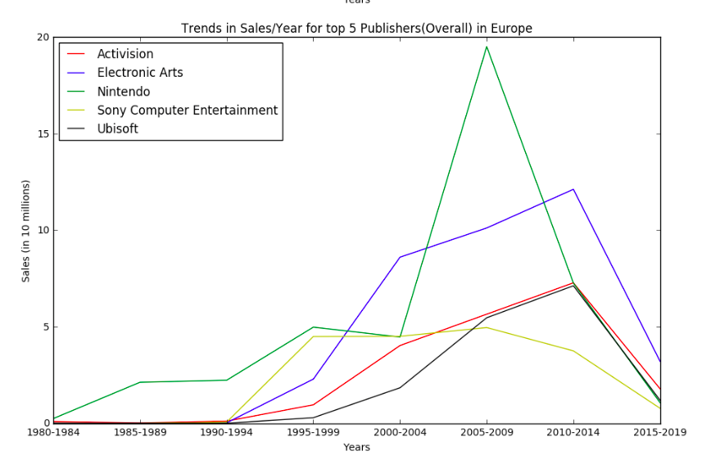

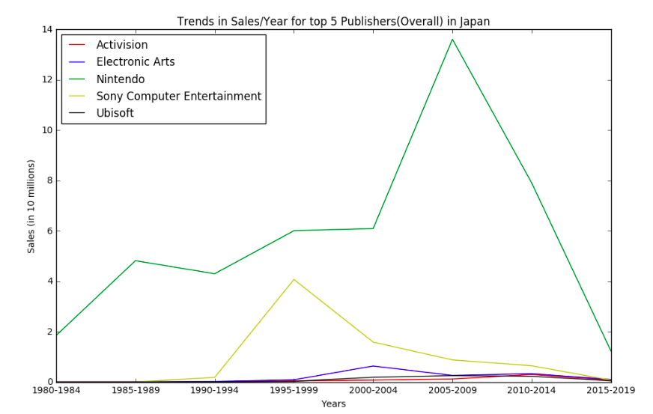

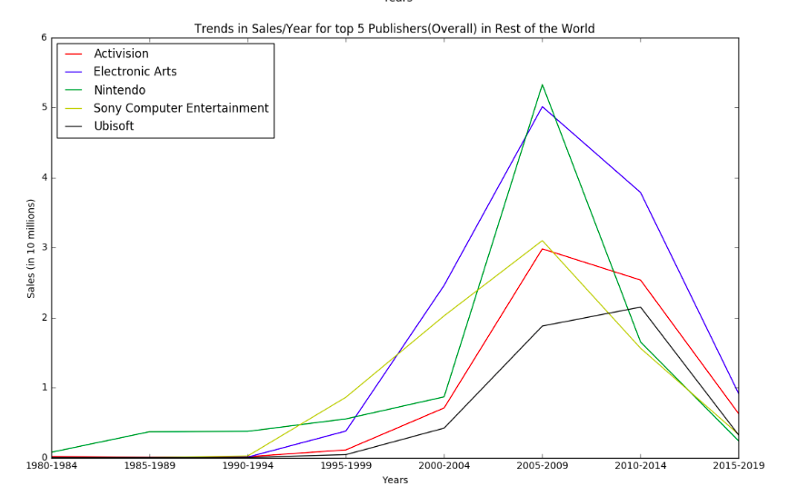

## Conclusion

Top 5 publishers based on the global sales are: Electronic Arts, Ubisoft, Sony Computer Entertainment, Activision and Nintendo.

From the plots above, we can see that:

1. There has been a sharp rise(increase) in sales for Nintendo for all regions in period 2005-2009.
2. Nintendo has been the oldest publisher in the world, accompanied by Activision whereas the other three publishers came into the market at later stages.
3. Sony Computer Entertainment had good sales in first 10 years but then it has seen continuous decline in sales across all regions.
4. We can also see that all the publishers had highest number of sales during the years 2005-2009 and sales fell drastically for each the publisher in all the regions for the corresponding period (2010- 2014).
5. Also, third plot strengthens our claim in previous objective that Nintendo has performed exceptionally in Japan as compared to other publishers.